**Experiment 8:Create and Test a Lambda Function with Triggers and DynamoDB Integration**

Search for the Lambda service

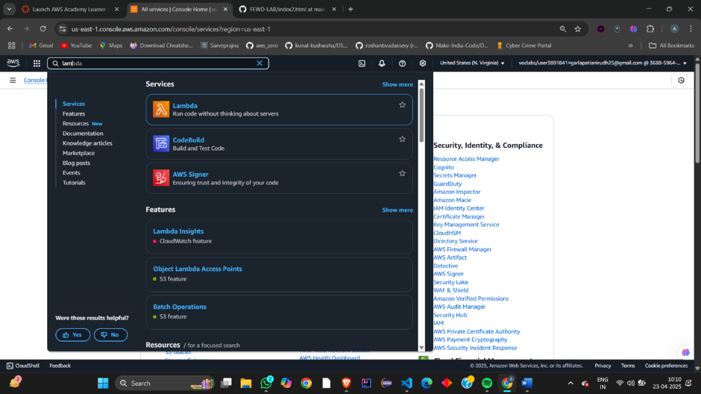

Lambda -> Functions -> Create Function to create a new function in Lambda.  
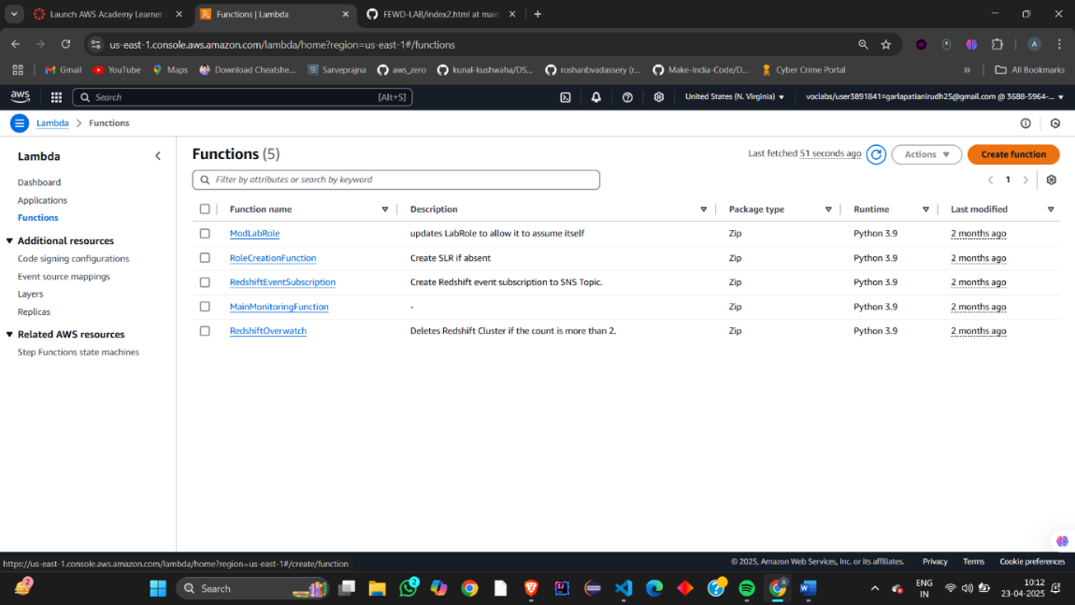  
let the author from scratch be same  
and give some valid name to function- 8a-function  
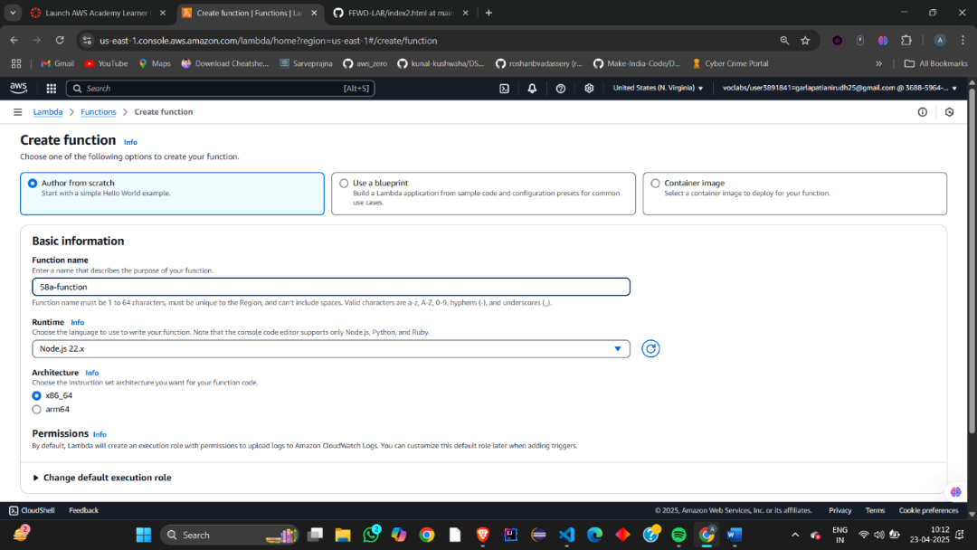  
From the dropdown choose the runtime and Python 3.9 is preferrable.

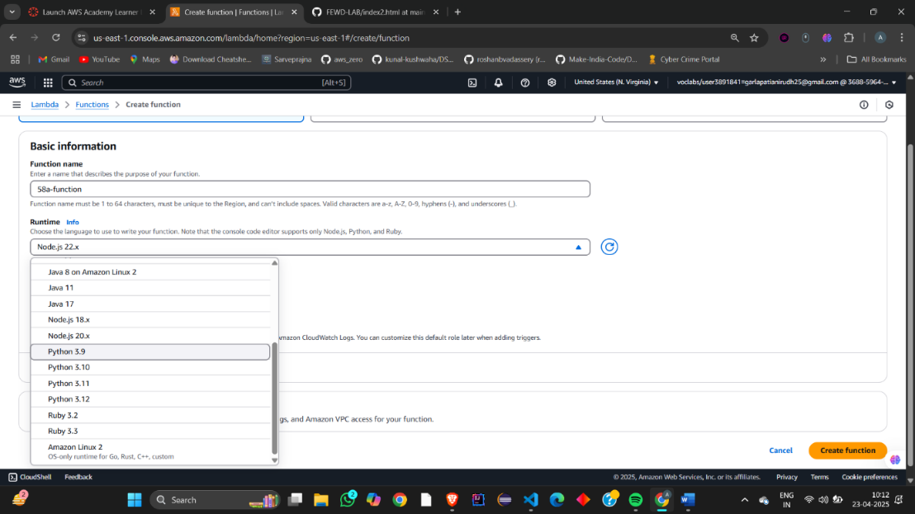  
Let the Architecture be x86_64 as default.

choose the Execution role, so Check the Use an existing role option. And click on create function   
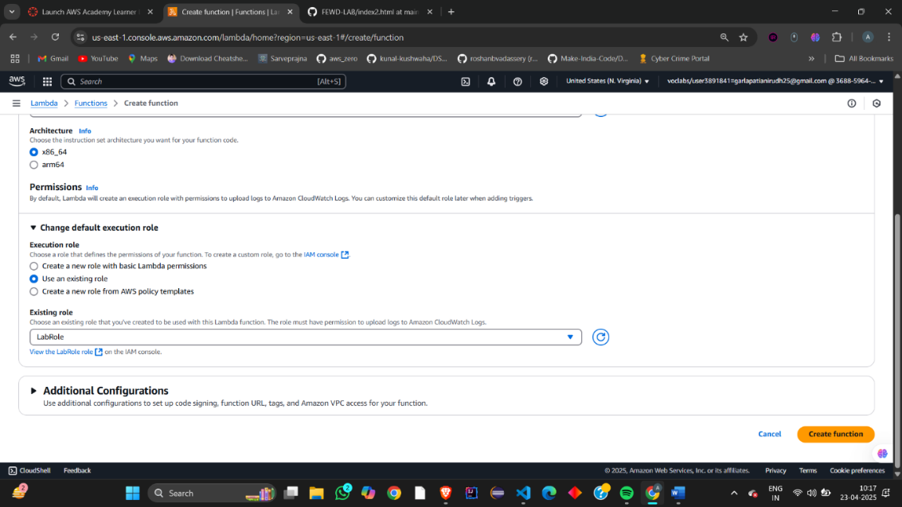

We have successfully created a new function

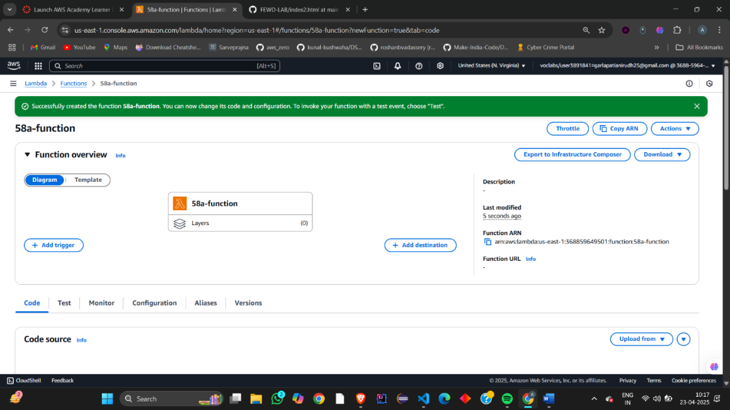  
Now go to Lambda -> Functions -> func58a -> Code and this would be displayed as it is default which says hello from lambda even in the console.  
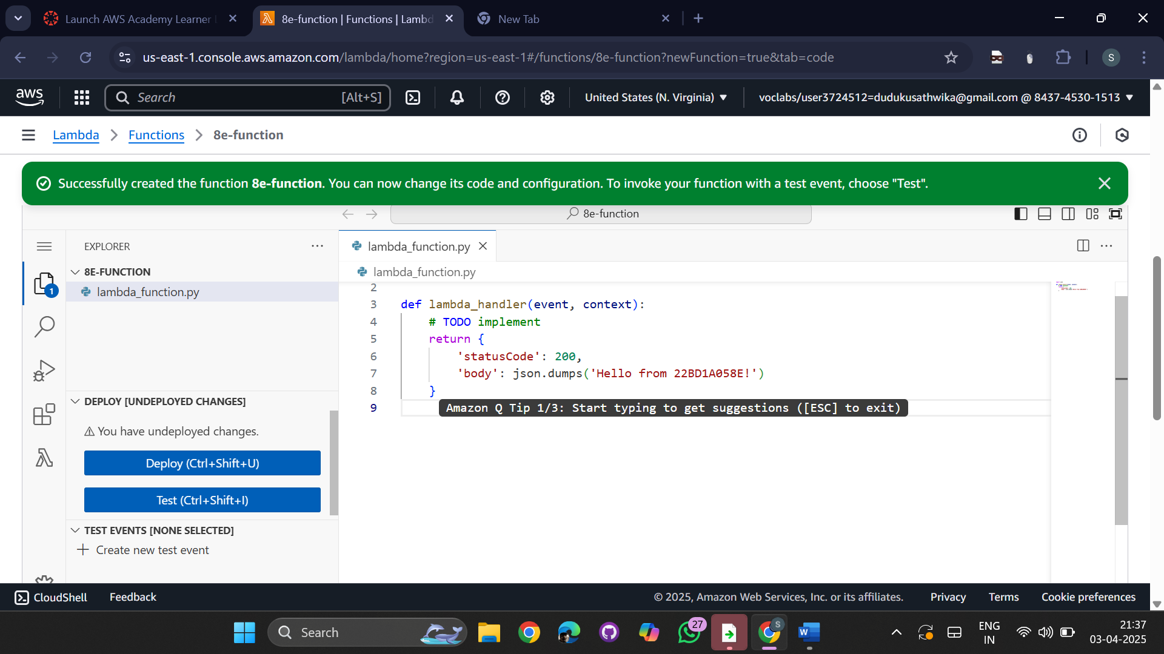  
And after that click on Deploy option to deploy our code .

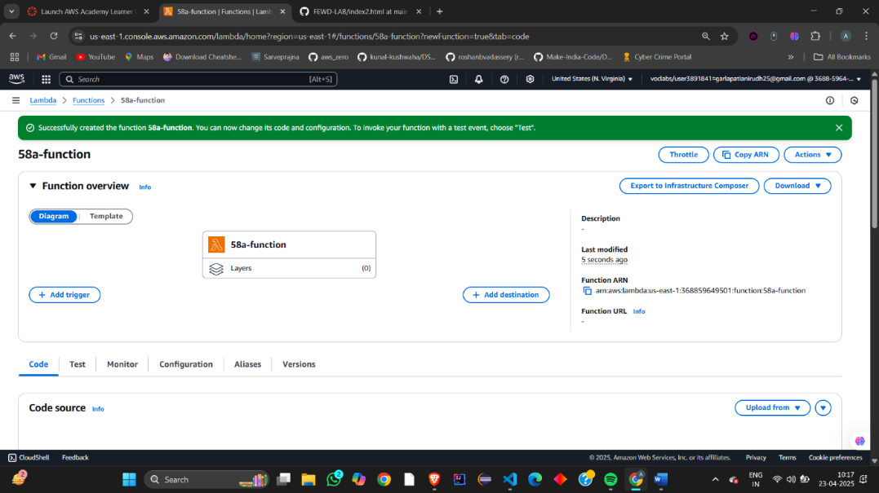  
click on test option  
And to test it we need to create a new 8e-test   
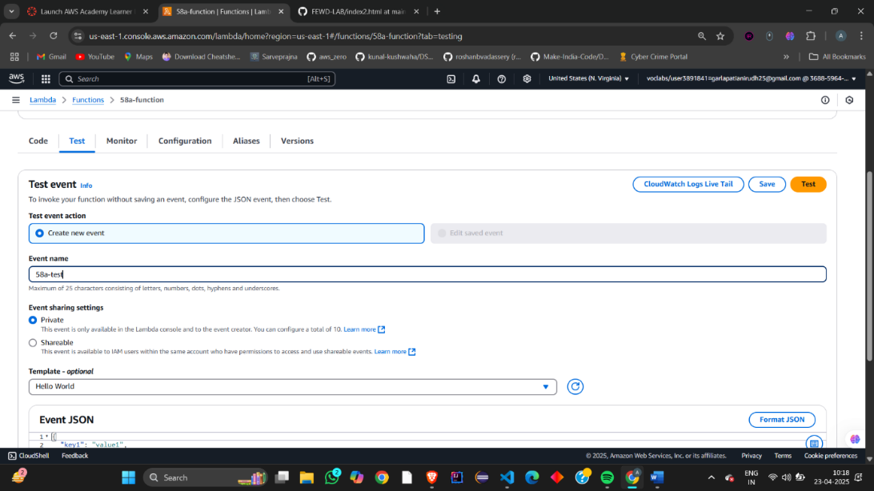  
  
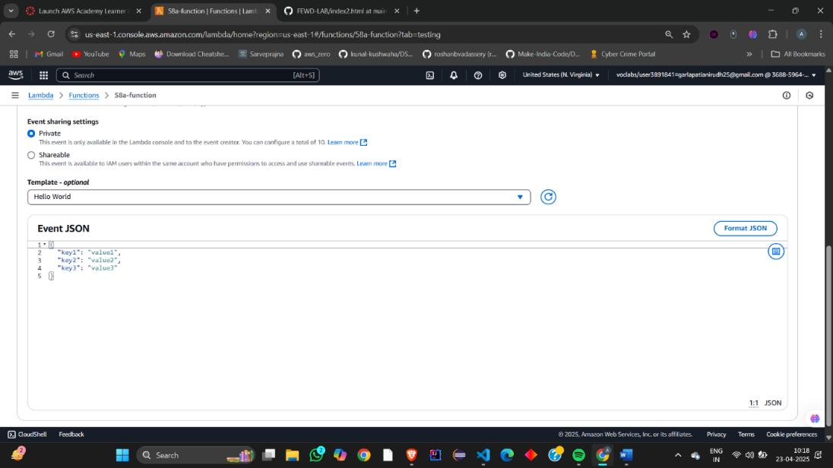  
As we can see here , Under the Details our changes have been updated.

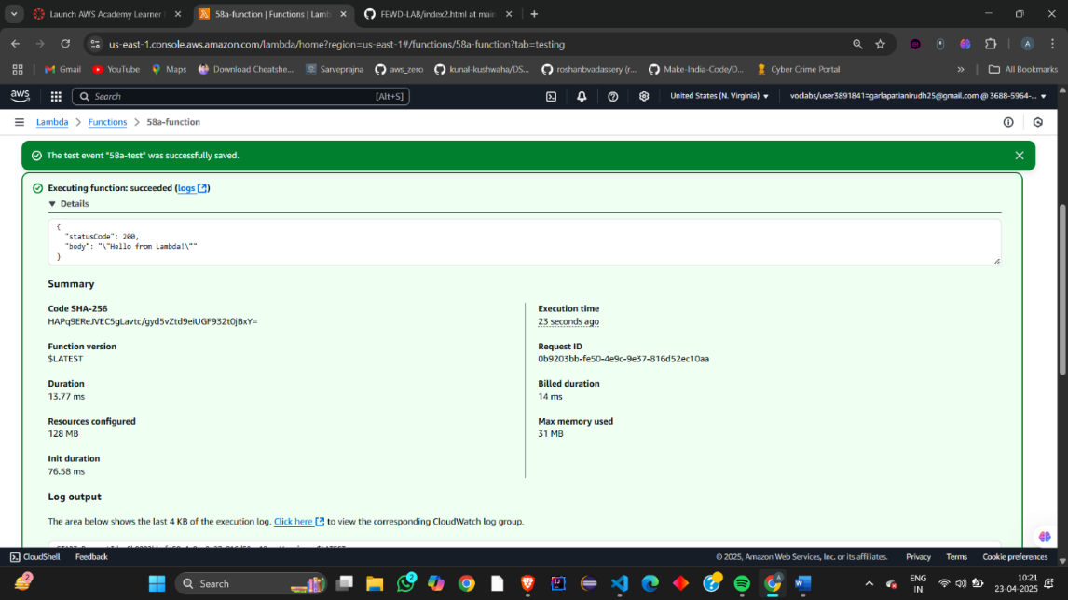

Also these the body of the code also appears at OUTPUT console.

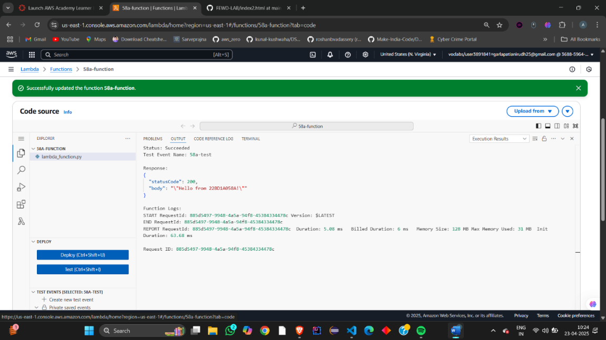  
Our function can be accessed through a URL but by default there will be no URL, we need to set one.

Head to Lambda -> Functions -> 8a-function -> Configuration and click on Create function URL.  
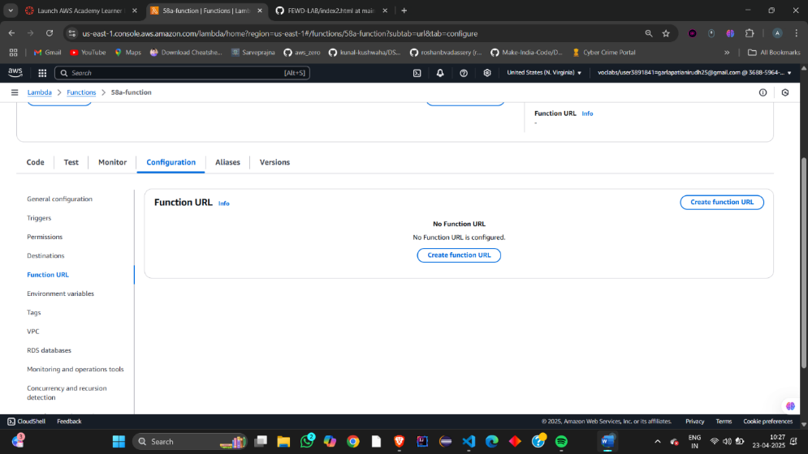

Let the Auth type be AWS_IAM to authenticated IAM users and roles can make requests to your function URL. And click on save button.

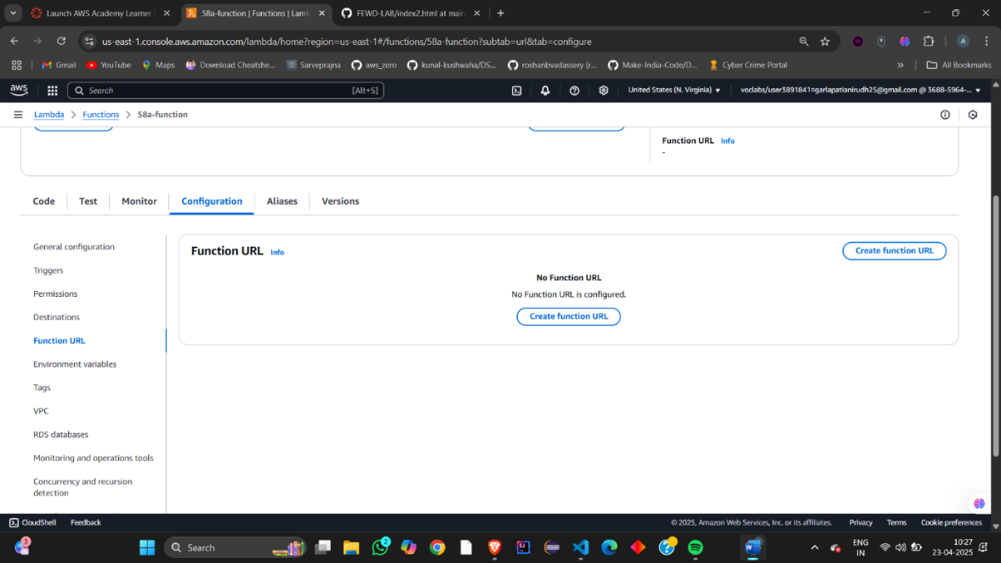

Changes have been successfully saved and there appears the URL.  
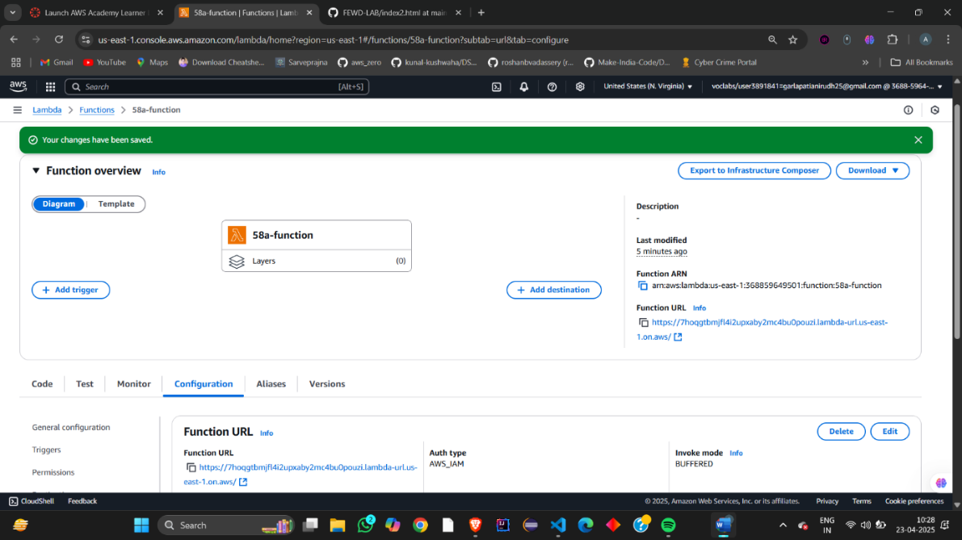  
Now paste the copied url in browser  
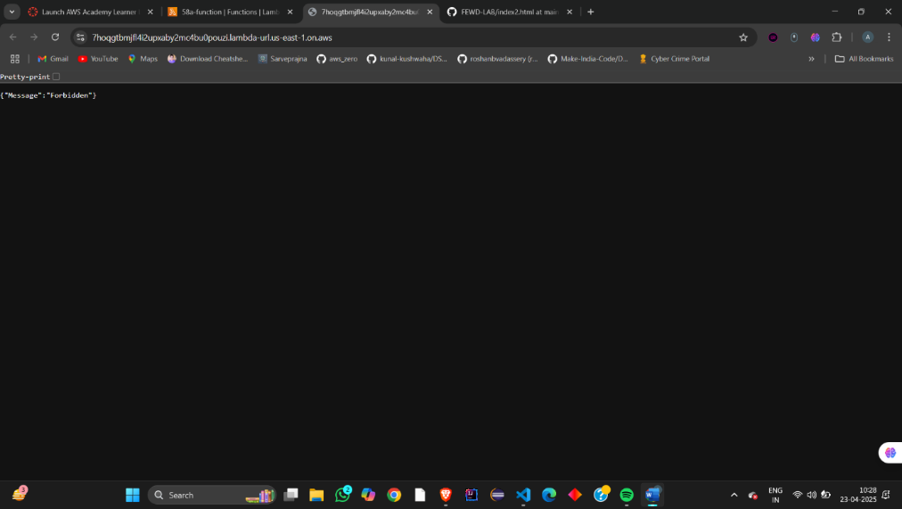

open a github repository  
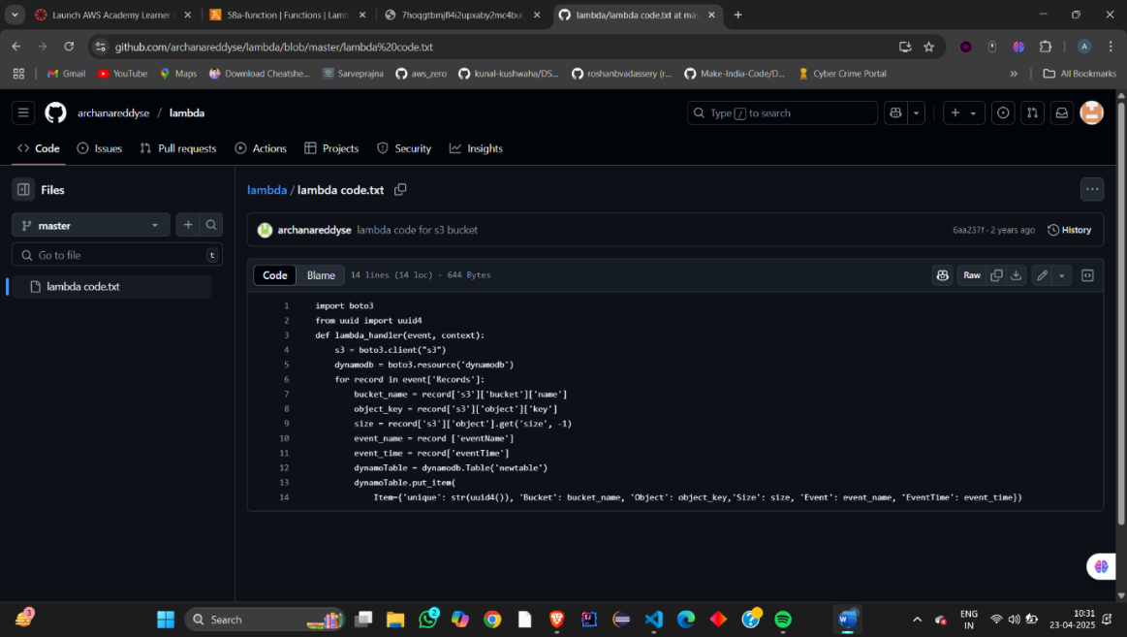

Now :  
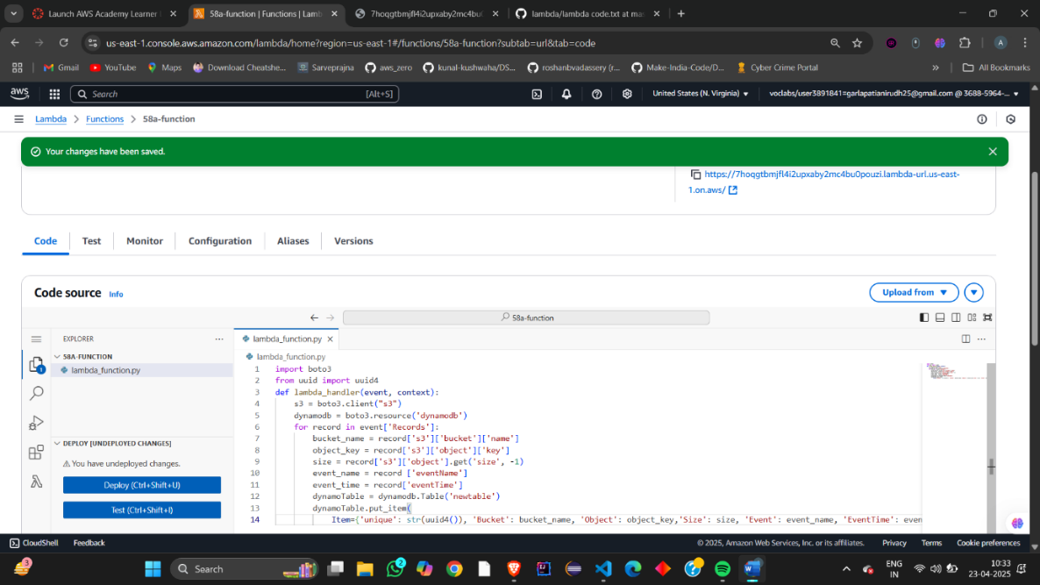  
create a s3 bucket:  
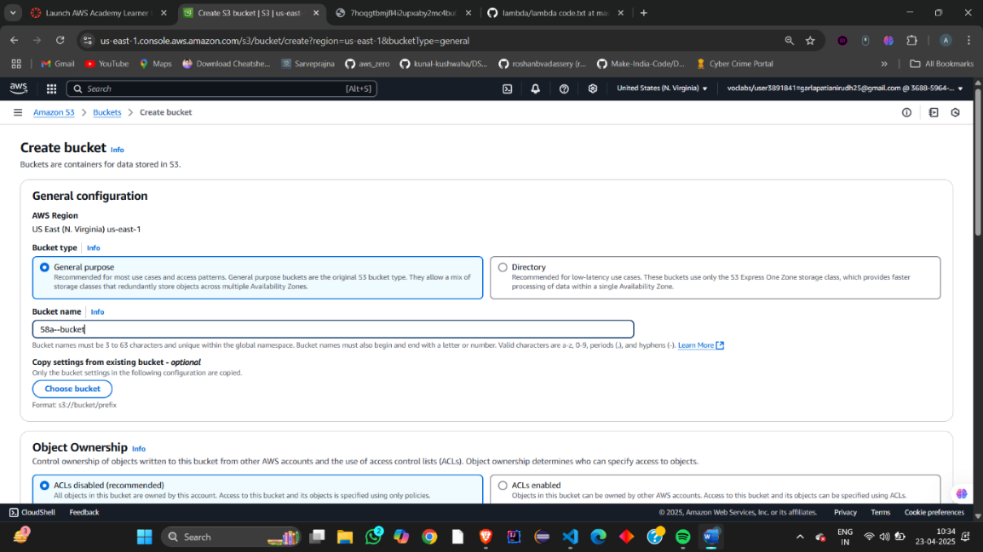  
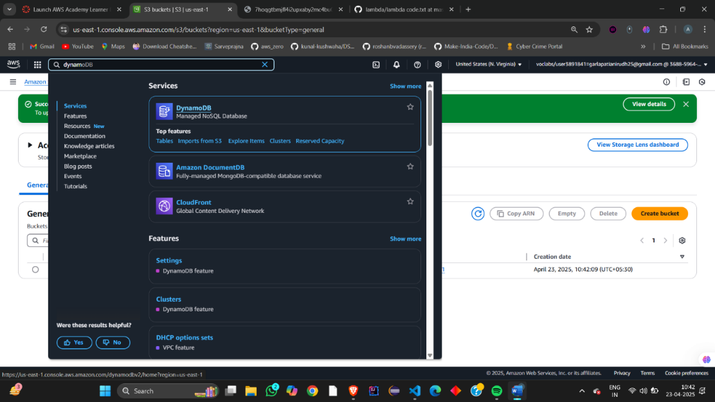  
  
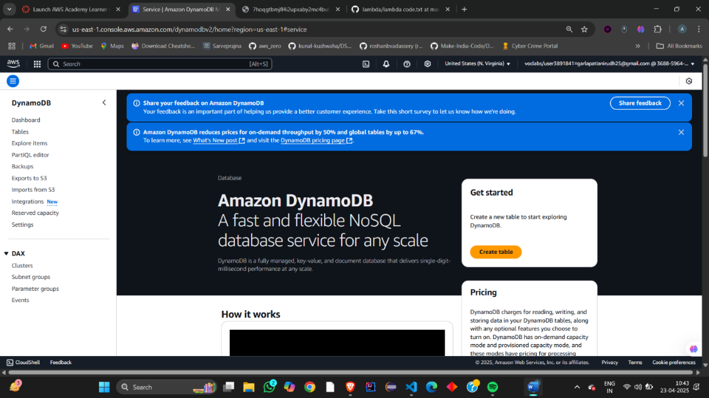  
  
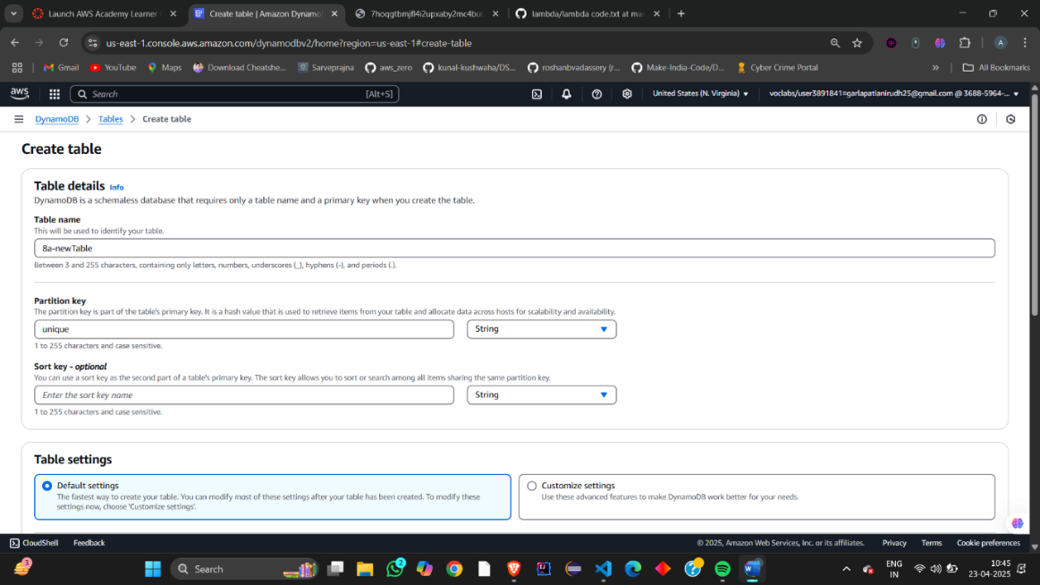  
  
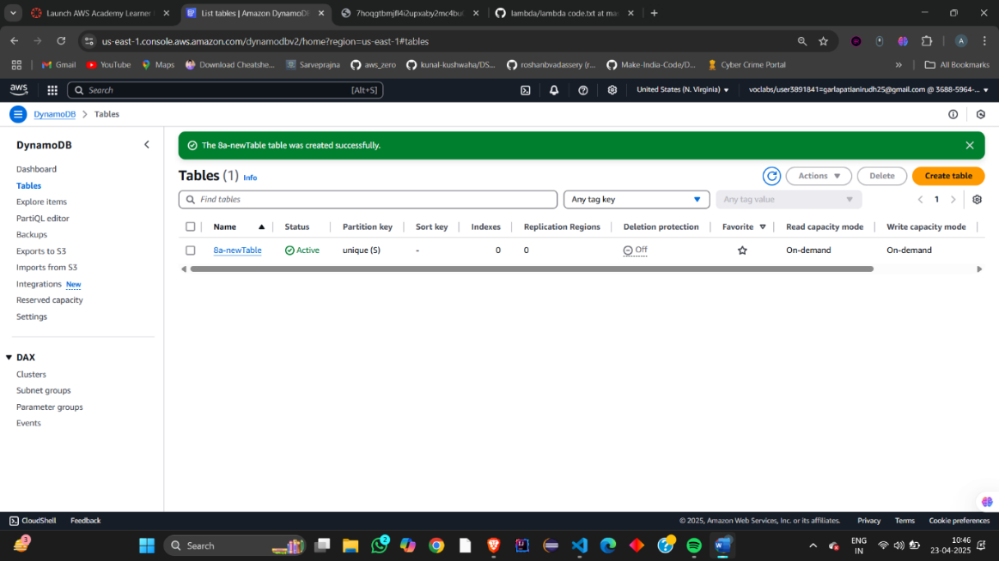  
deploy the code  
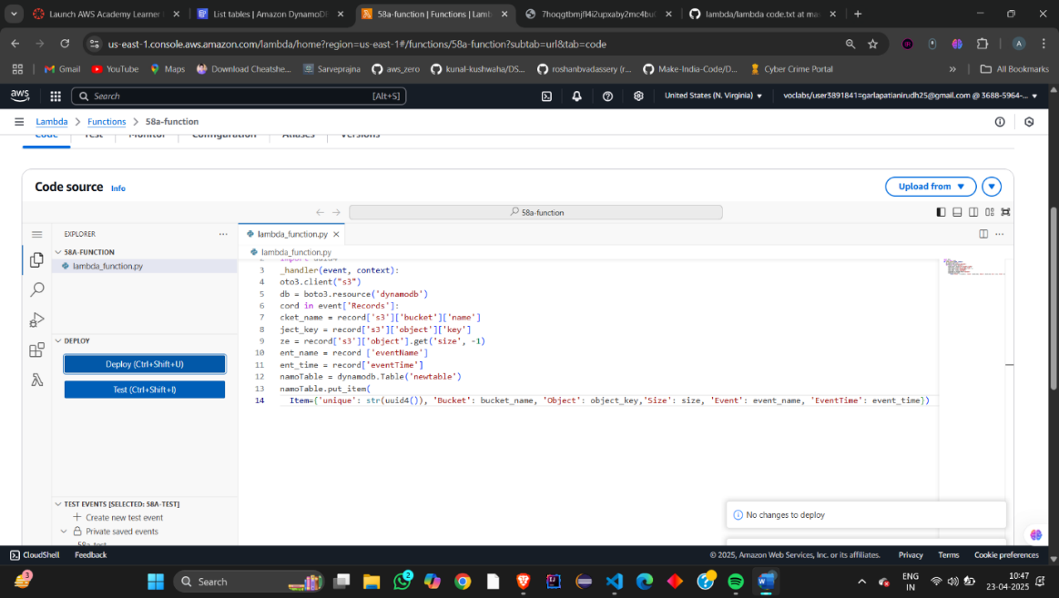  
  
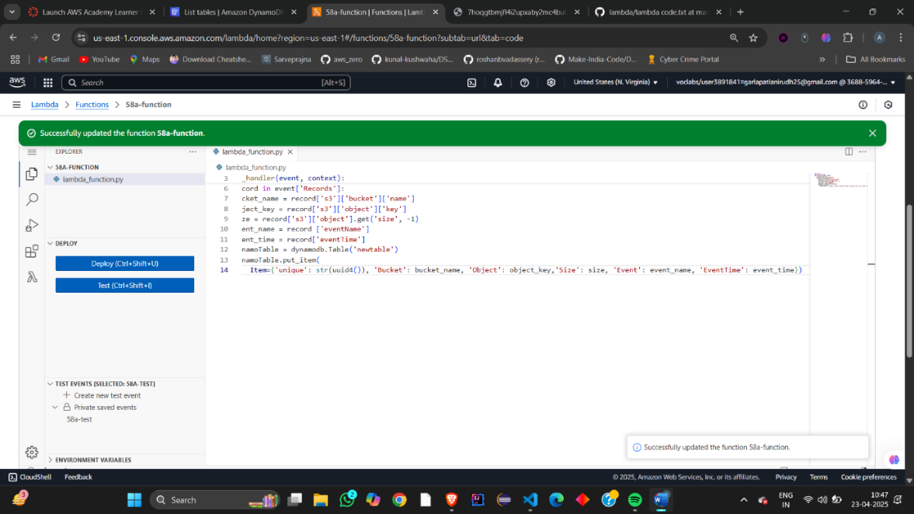  
  
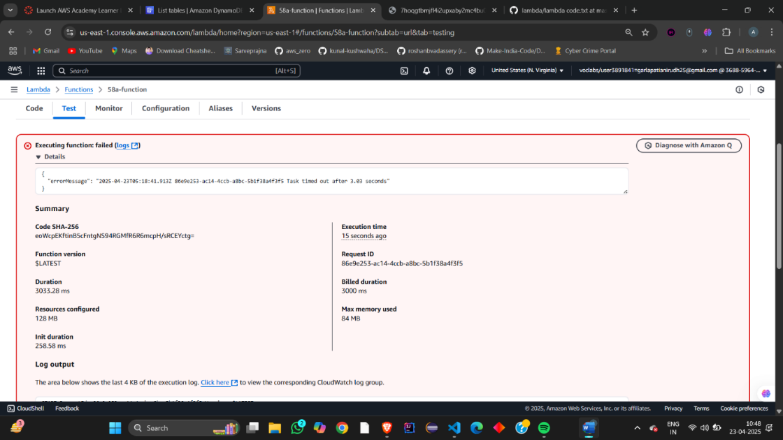

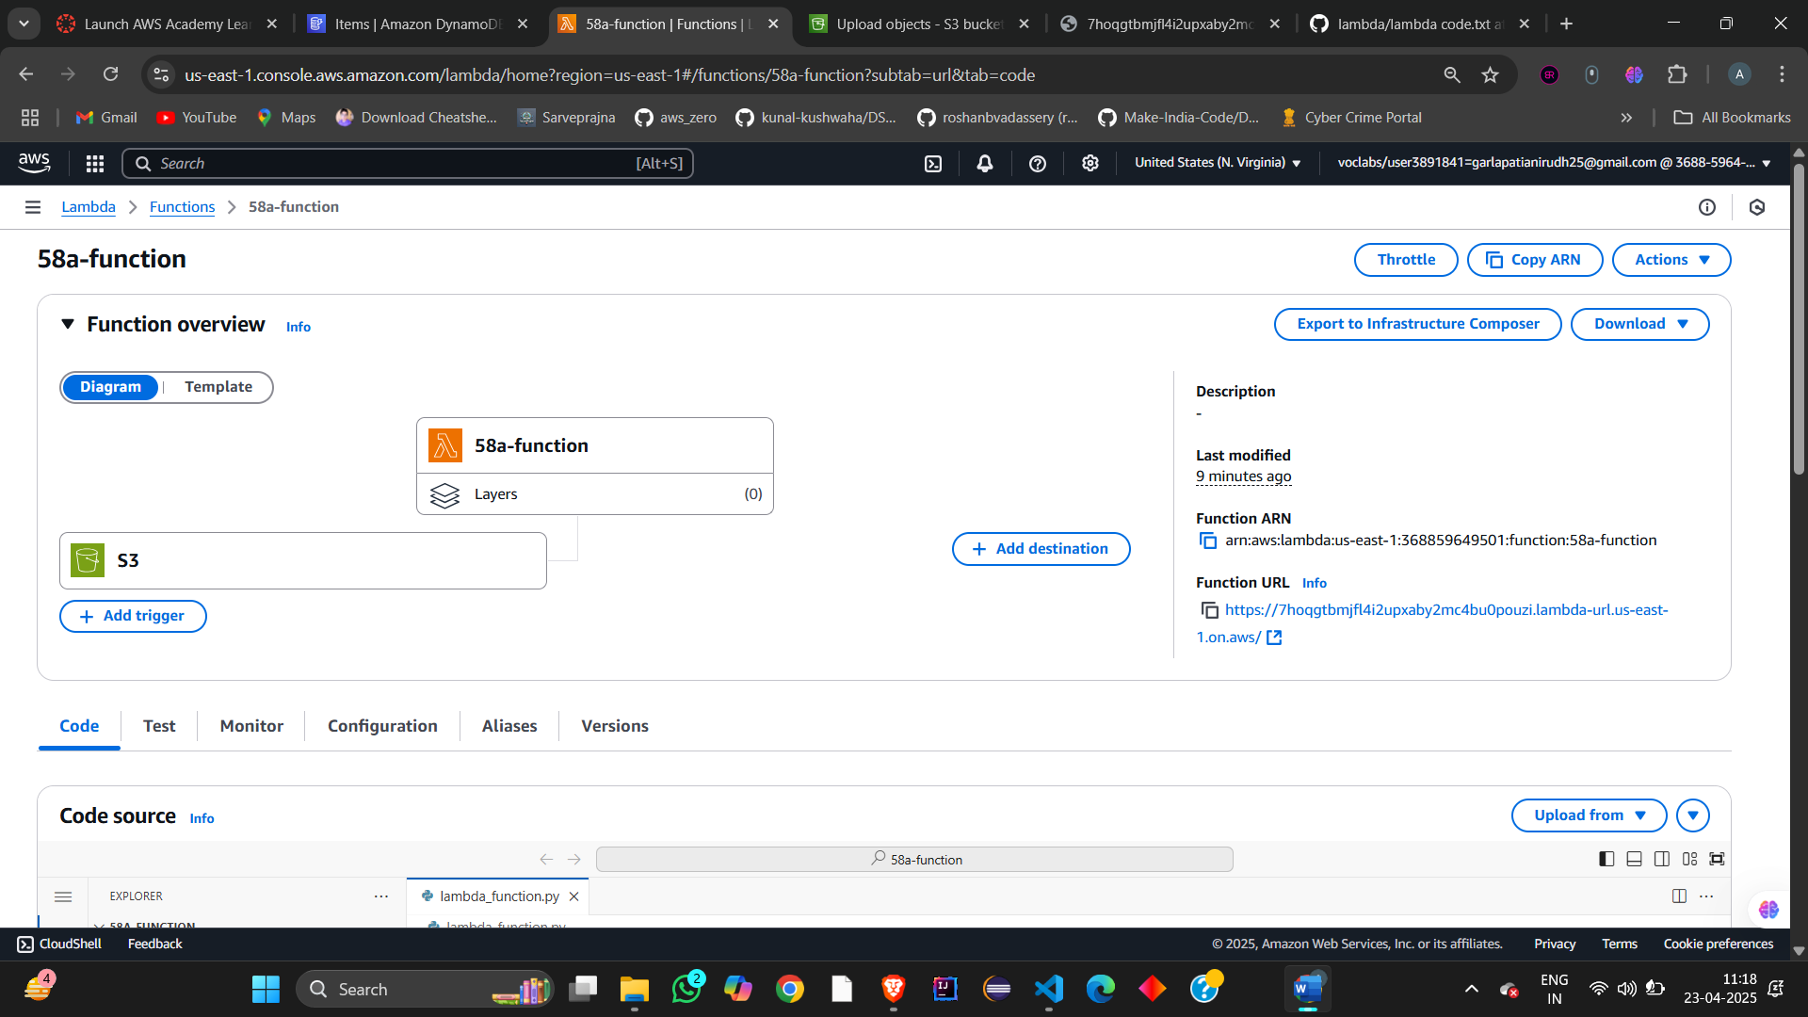  
  
  
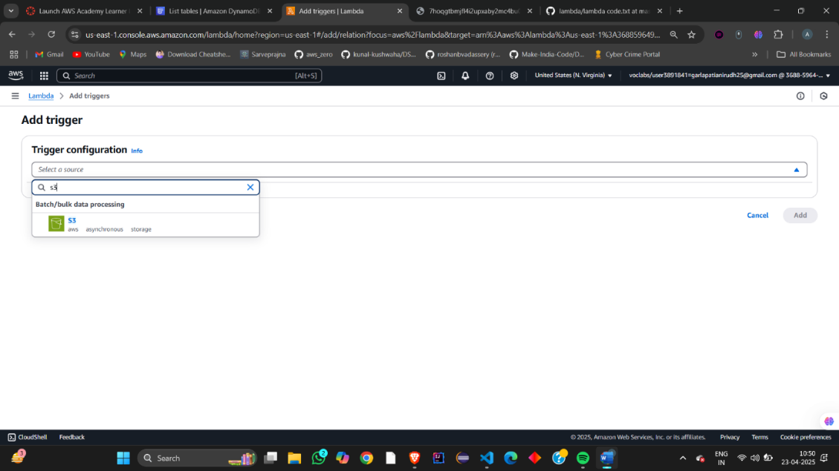  
  
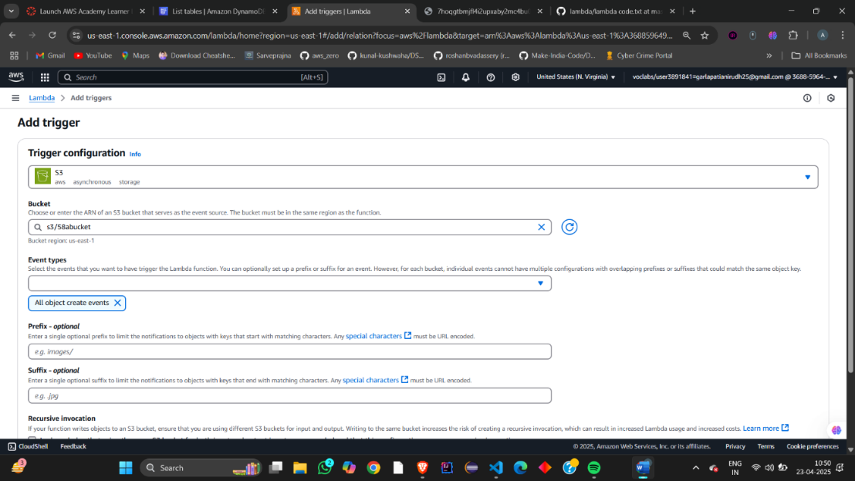  
  
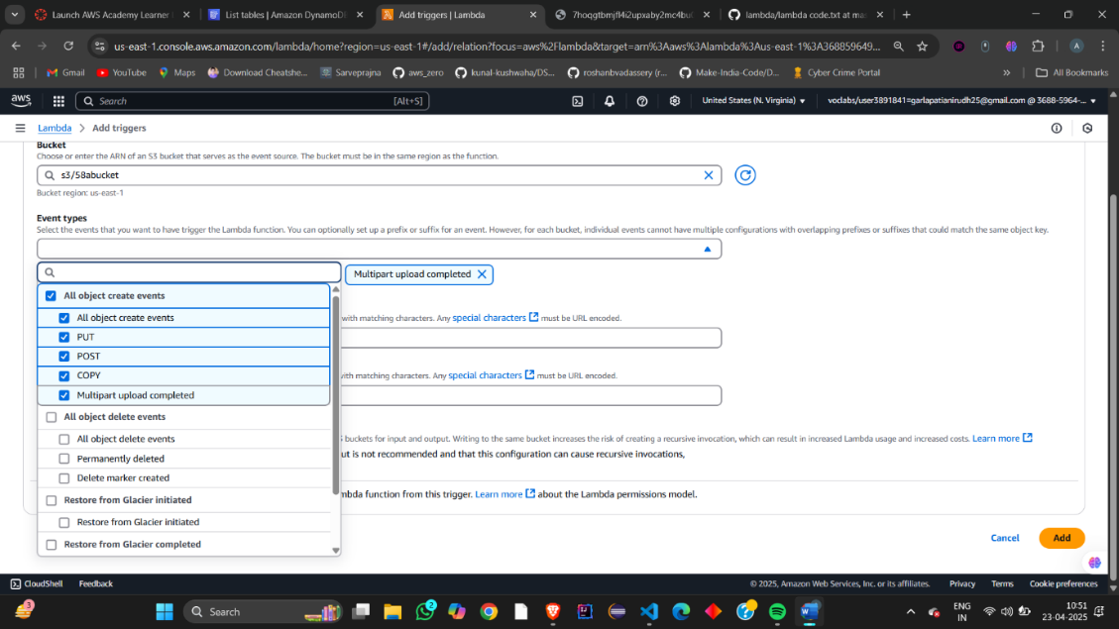  
  
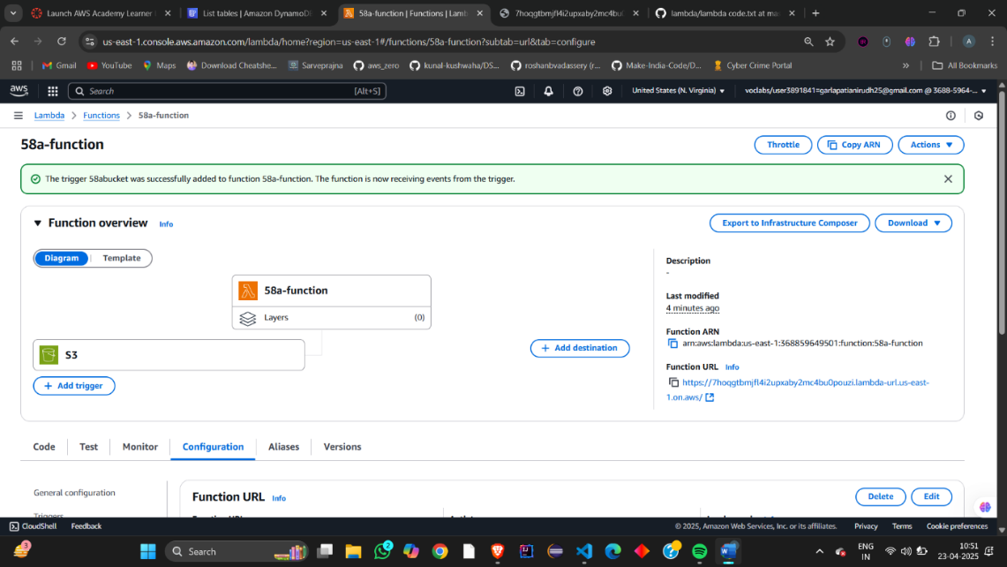  
  
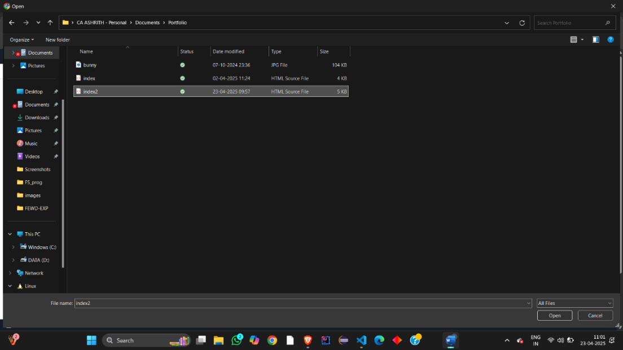  
  
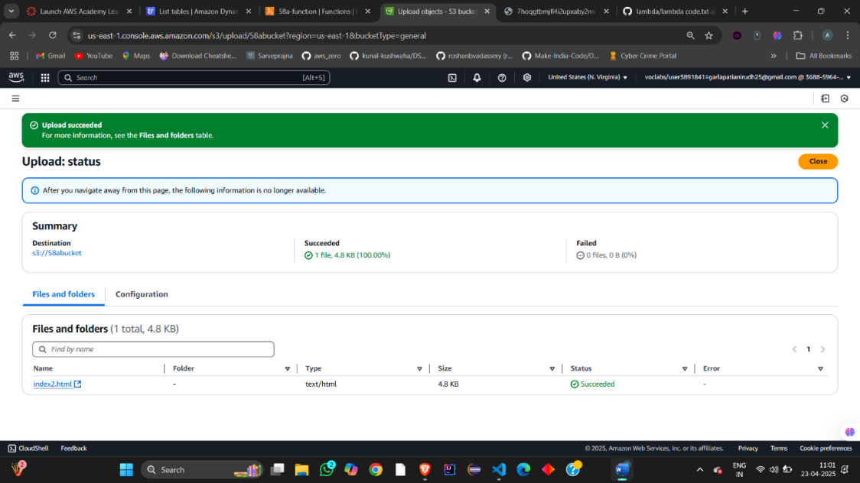  
go to explore items  
